**Intellectual Disability with motor skills**

Intellectual disability that affects motor skills have problems with both gross and fine motor skills. They may seem uncoordinated for their age and have significant problems with movement that require hand to eye coordination.

**Sip-and-puff systems**

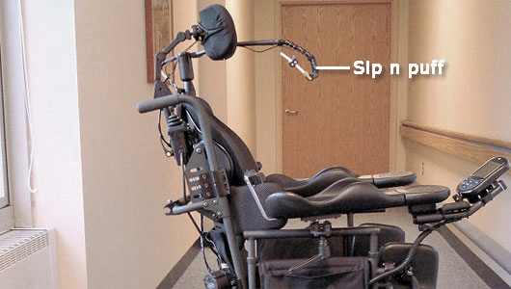Sip-and-puff systems are used by people with mobility disabilities, such as paralysis and fine motor skill disabilities also used for quadriplegics(paralysis) caused with high injury to their spinal cord or ALS also Known as MND(motor neuron disease). These systems allow for control of a computer, mobile device or some other technological application by the user moving the device with his or her mouth. Similar to a joystick, An on-screen keyboard allows the user to type using the same movements. For people effected with severe motor disabilities, manipulating a standard switch can be difficult, tiring and in some cases impossible. With Origin Instruments Sip/Puff offerings users can easily activate and have control over devices through a simple "sip" and/or "puff" into a mouth tube. The amount of pressure are typically denoted as a hard sip/soft puff, however other terminologies might exist.

Use the second-generation Breeze to access iPad, iPhone and the iPod touch with Apple's Switch Control feature. There are several ways to configure a sip and puff switch solution. The first consideration is the user interface. There are two styles of headsets, single-user and multi-user, and a gooseneck user interface. The multi-user headset features a totally detachable mouthpiece assembly that is easily replaced for situations where multiple people will be using the same Sip/Puff Switch. For situations where a headset is not desired, a flexible gooseneck style interface is available. The gooseneck user interface features twist-on filtered mouthpieces.

**What can we do with this tool?**

Typical applications of sip-and-puff devices are for control of motorized wheelchair (An initial hard puff will enable the wheelchair to move forward while a hard sip will stop the wheelchair, conversely a hard sip will enable the wheelchair to move backward while hard puff will stop the wheelchair) , the sip n puff interface is used as a digital interface meaning it is used for simple on and off operations. However the actual sensor that is used in these systems is capable of reading analog signal/input which lets the user vary the amount of pressure they are exerting for different effects With this in mind here are just a few examples uses

* Mouse Button Emulation(Hands free operation of mouse operations like left click and right click)
* Joystick Button Emulation
* Keyboard Emulation
* Apple iOS Switch Control Events
* Expressive control over variables relevant to the task at hand like varying the width of the paint brush strokes while drawing.

**Pricing**

There are commercial sip and puff interfaces out there today, but they are all very expensive(hundreds to thousands of dollars) and may be hard to figure out. Many are used for directly controlling wheelchairs, while others are quite difficult to pair with a computer and make use of.

**An open source Sip-and-puff mouse**

A sip-and-puff can make a world of difference to a quadriplegic but they are not exactly cheap. So to help out a friend [JfieldCap] designed and built an open source sip-and-puff mouse on the cheap. As is beat for such devices, handle for a joystick module, and a length of tubing connects the mouthpiece to the pressure sensor. An Arduino lets the user move his head to position the cursor while hard sips and puffs are interpreted as left and right clicks and while soft mouse pressure is used as scrolling. In conjunction with some of the accessibility tools in modern OSes and personal assistants(Siri and Cortana) this tool opens up the online world for all of a 50USD material.